A Minor Project Report

On

**Buddy**

Submitted in partial fulfillment of requirements of the

Degree of

**Bachelor of Technology**

In

**Computer science**

**Under the guidance of**

**(Ms. Renu)**

**Asst. Professor**

**School of computer science**

**Submitted By-**

Harshit Yadav  Soham Kundu

(14CS003) (14CS015)

Department of Computer Science

**LINGAYAS UNIVERSITY,FARIDABAD**

December, 2016

(Annexure 1)

**CANDIDATE’S DECLARATION**

I hereby declare that the work presented in this report entitled ‘Buddy’ in fulfillment of requirement for the award of degree of Bachelor of technology in Computer Science, submitted in Computer Science Department Lingayas University, Faridabad, is an authentic record of my own work carried out during my degree under the guidance of Ms. Renu.

The work reported in this has not been submitted by me for award of any other degree or diploma.

Date:22 December 2016 Harshit Yadav

Place: Lingayas University Soham Kundu

(Annexure 2)

**CERTIFICATE**

This is to certify that the project entitled ‘Buddy’ submitted by Harshit Yadav and Soham Kundu in fulfillment for the requirements of the award of Bachelor of Technology degree in Computer Science at Lingayas University is an authentic work carried out by them under my supervision and guidance. To the best of my knowledge, the matter embodied in the project has not been submitted to any other University/ Institute for the award of any degree.

Date: 22 December 2016 Ms.Renu

Asst. Professor

(School of Computer science)

(Annexure 3)

**ACKNOWLEDGEMENT**

I express my sincere gratitude to Mr. Tapas Kumar (HOD, CS) for his valuable guidance and timely suggestions during the entire duration of my dissertation work, without which this work would not have been possible. I would also like to convey my deep regards to all other faculty members of Computer Science Department, who have bestowed their great effort and guidance at appropriate times without which it would have been very difficult on my part to finish this work. Finally I would also like to thank my friends for their advice and pointing out my mistakes.

(Annexure 4)

**ABSTRACT**

At present the College Management Systems and Other ERP Systems that are implemented in the Educational Institutions are more of the age old traditional systems with much of the tools, resources & benefits in the hands of the Department assigned in the management and maintenance of the System With the help of our project named “BUDDY “we plan to give more productivity and tools out of the ERP System to the End user so that they can be benefited from it and can use the results and stats given by the software for better work productivity, along with efficient time management between the schedule

**CONTENTS**

1. CANDIDATE’S DECLARATION…………………………………… ……...Annexure 1
2. CERTIFICATE………………………………………………………………...Annexure 2
3. ACKNOWLEDGEMENTS……………………………………………………Annexure 3
4. ABSTRACT……………………………………………………………………Annexure 4
5. CONTENTS

**CHAPTERS:**

**I Introduction**

i Aims and objectives…………………………………………………………...................page 7-9

ii Outline…………………………………………………………………….......................page 10

**II Functionality**

i How does it work?.........................................................................................................page 11-13

**III User interaction**

i Why Qt platform?.......................................................................................................page 14

ii ScreenShot………………………………………………………………………….page 15

**IV Platform** ……………………………………………………………………………page 18-19

**V Conclusion**

i Summary………………………………………………………………………….……page 20

1. FUTURE SCOPE…………………………………………………………..............page 21
2. REFERENCES……………………………………………………………………..page 22
3. CHECKLIST………………………………………………………………..…Annexure 5

**CHAPTER -1**

**Introduction**

The objective of the project is to build a software that is specifically designed for the Students in the Educational Institutions with aim of providing them with a tool that can help them in planning their study schedule and also in their lectures and attendance and calculate the amount of effort required by them to achieve their targeted CGPA based upon the prediction of their CGPA as per their current marks in the field. The Software also contains various other tools and utilities that will help them in their academics.

The basic question that primarily arises for any proposed project is why it is essential to build it. Well here we are going to justify why there is a need to create such an application.

* 1. **AIMS AND OBJECTIVES:**

We in this software solution have designed and implemented an ecosystem of closely related tools which are in context to the 21st Century student, Faculty and his institution.

The main objectives for this project are as follows:

* + - To create one stop information portal.
    - To provide better memory and time management to users.
    - Increased accuracy and reliability.
    - Increased efficiency.

This software package can be readily used by non-programming personal avoiding human handled chance of error. This project is used by different types of users-

* + - * + IT Department
        + Students
        + Faculty
        + Management

IT Department will definitely use this application to see the latest and most used types of web applications. It’ll also give them more ideas to be creative in their fields.

Management have to observe the latest trends and then plan various strategies for working or implementing different ideas. This project can easily be used to observe the latest trends in general

Basic users are those who are just searching on a particular topic. Here they can easily find their answers.

And lastly the admin user who will handle, update and maintain the page so that it can work as efficiently as possible. New features can easily be added as per the requirement.

* 1. **OUTLINE:**

In a nutshell the following report will explain and summarize our project in a more clear way. But it can be easily stated that the main functionality of this application will be to save time and be more user friendly and easy to use. From interface to working everything in this application is of basic level so that anyone can use it and gain maximum benefit from it.

**CHAPTER-2**

**FUNCTIONALITY**

**2.1 How does it work?**

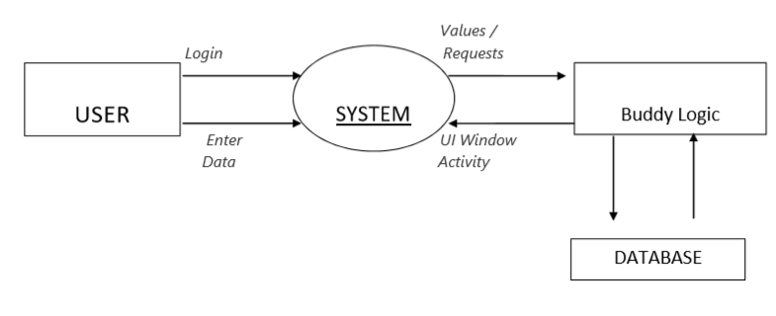

As the above figure suggests this application primarily has three functionalities-

1. **Google Widget**

Buddy is a one stop application for many solution ,we felt the need that the user might query the net and what better way to do so than the almighty google, so we cut the task short and created a local variant of the google search engine with the google suggest functionality, keeping the same minimalistic interface as that of its backend .So now the user can query his question directly from the software without going to the browser.

1.1. Student effort:

Data Structures have been designed to keep organized the suggestions that will be provided once the widget establishes connection to its motherhub, also algorithms have been designed with the suggest functionality in mind.

1. **`Map Tool**:

Due to various intercollege meetings revolving round the clock your college is always remains the hotspot 365 days a year. Various new faces visit the college round the year so it is always a good idea if the new visitor has whereabouts about the journey and his destination. Thus, the MAP tool provides a customized street view experience and highlights points of interest.

2.1. Student effort:

* Here we have implemented customized route detection and mapping algorithms in conjunction with the google maps API (In beta phase )
* Future plans to incorporate the same from khedi bridge to our college (hindrances physical surveying)

1. **Calendar:**

This module has been designed so that the user can have his own calendar on which the user can mark the highlights that he needs to be done for the day.

3.1. Student effort:

Data Structures have been designed to keep track of the event scheduled for the day and appropriate timer have also been designed to keep track of the event. Database functionality has been made local for experimentation purpose.

1. **Notification Portal:**

In this module we have created a central hub for accessing and getting notified about the University announcement and other updates across the various multiple online social media domains

4.1. Student effort:

Each tab of the application has been mapped to its associated online data source which is fetched during the launch in background to load all the data before the user accesses this particular module

1. **Question Bank :**

This module has been created to assist the faculty and the examination department in the creation of question paper and feedback forms in a automated manner by the selection of data from the collection of database.

5.1. Student effort:

Custom Algorithm has been designed to randomly select the data from the database and generate a structured document file in the local drive

1. **Marks Prediction:**

Scoring good marks is the end goal of every student in the institution thus CGPA estimation tool has been created to predict the end CGPA based upon the current score.

6.1. Student effort:

Designing a prediction algorithm based upon the institutions current marking and grading scheme.

1. **Ai Bot :**

A Facebook Messenger based Assistant based on the Facebook bot API to work as a Bot and provide a chat interface based assistance and data from the data source repository to serve as a virtual companion to students and faculty .

7.1 Student effort

Designing, hosting the backend and designing the Bot Functionality.

**CHAPTER-3**

**USER INTERACTION**

* 1. **Why Cross platform?**

In this project we are converting our pre-existing website into an android application as it is much more effective and has vast number of advantages over the conventional websites that we see every day. Some of the benefits are listed below:

1. **Low barrier to entry:**

Qt has low barrier to entry. There are no costly licensing fees or development tools. The primary costs fall into three categories: development and testing expertise, royalty fees and test devices.

1. **An ideal platform for newcomers:**

Qt applications are written in C++, which has a rich set of libraries. Anyone with a working knowledge of C++ can make an android application with much more ease.

1. **A variety of Distribution fields:**

Qt applications can be distributed in a variety of ways. One can use number of third party application stores but also can create one’s own distribution channel.

1. **Open and free platform:**

License free, royalty free and open source that’s android. No costly licensing fees. Also since the underlying architecture of the QML framework is open source one can get feedback about latest updates from android team. In android the entire platform is available for customization.

**Screen Shot**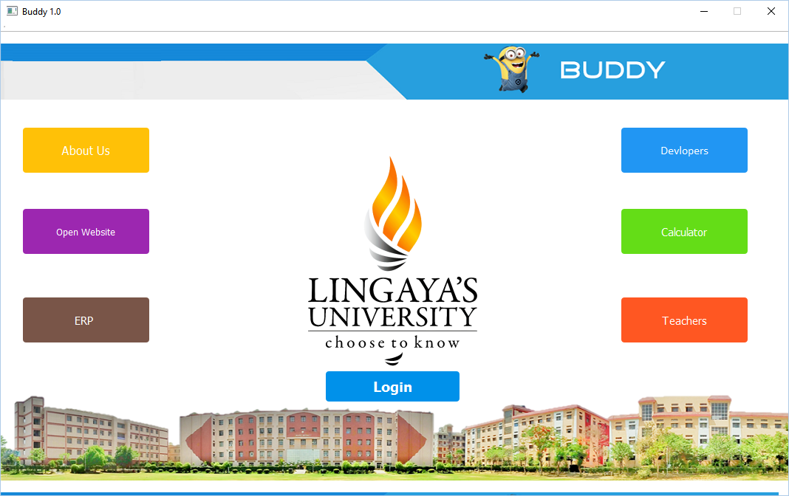

Main Window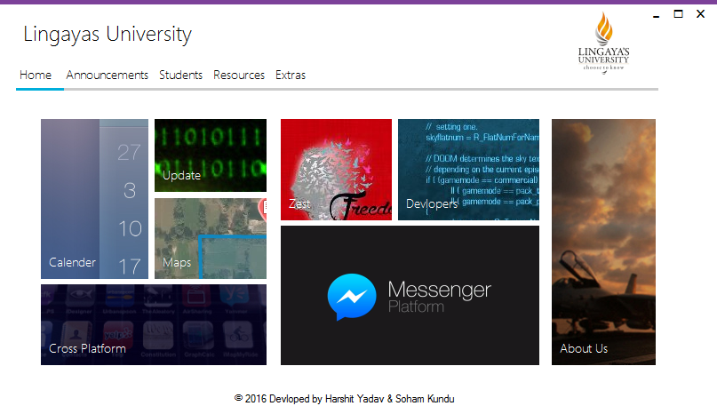

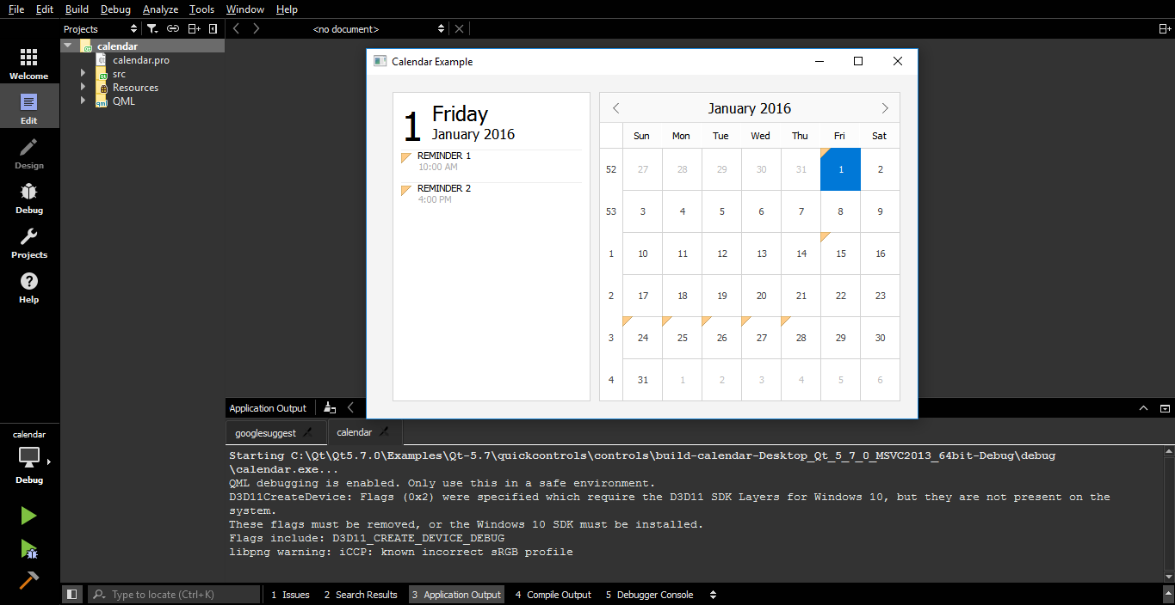

Calendar

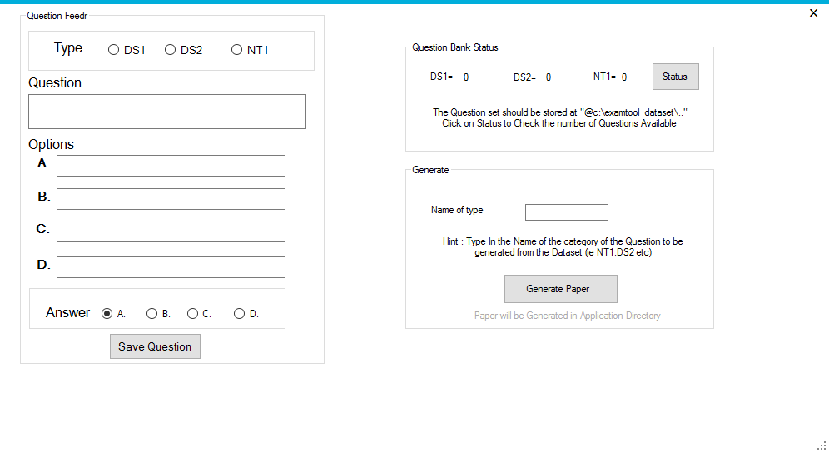

Question Paper Generator

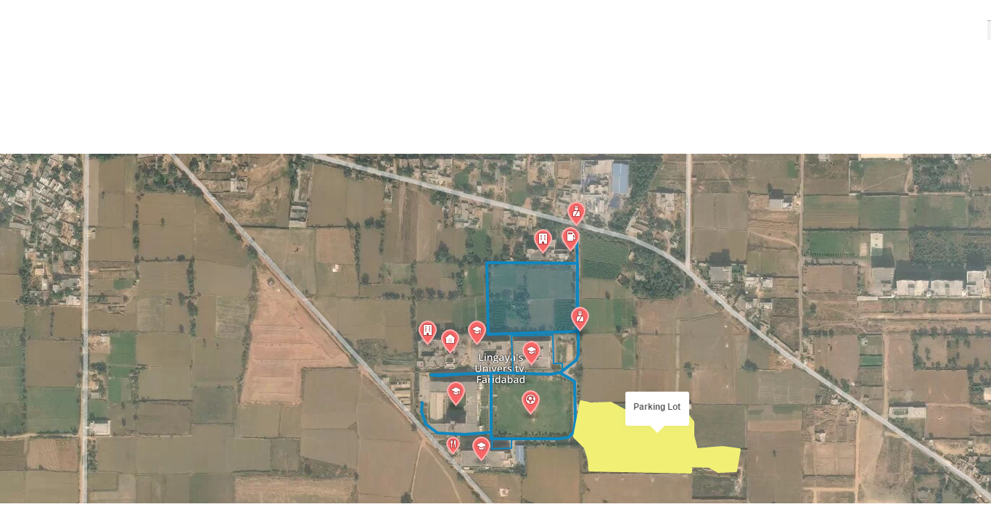

Map Utility

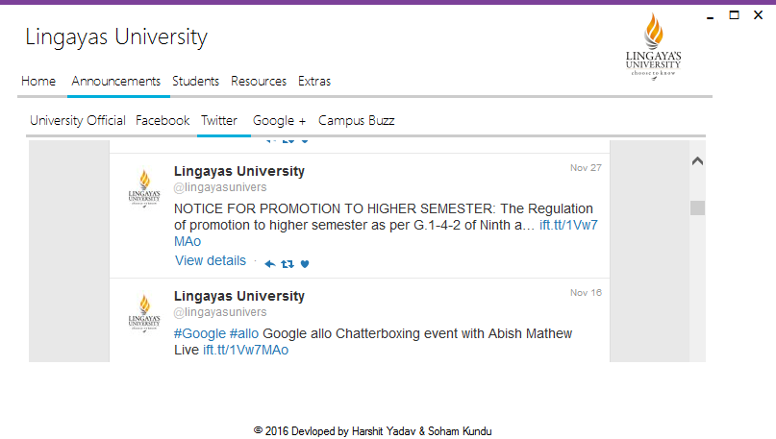

Notification

**CHAPTER-4**

**PLATFORMS**

**Tools and Platforms Used**

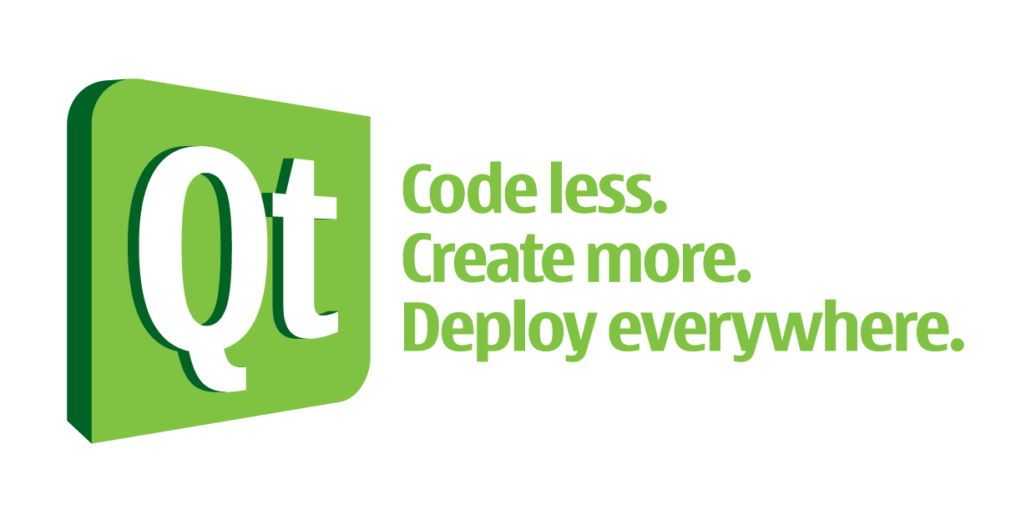

Qt is used mainly for developing application software with graphical user interfaces (GUIs); however, programs without a GUI can be developed, such as command-line tools and consoles for servers. An example of a non-GUI program using Qt is the Cutelyst web framework.[16] GUI programs created with Qt can have a native-looking interface, in which cases Qt is classified as a widget toolkit.

Qt uses standard C++ with extensions including signals and slots that simplifies handling of events, and this helps in development of both GUI and server applications which receive their own set of event information and should process them accordingly. Qt supports many compilers, including the GCC C++ compiler and the Visual Studio suite. Qt also provides Qt Quick, that includes a declarative scripting language called QML that allows using JavaScript to provide the logic. With Qt Quick, rapid application development for mobile devices became possible, although logic can be written with native code as well to achieve the best possible performance. Qt can be used in several other programming languages via language bindings. It runs on the major desktop platforms and some of the mobile platforms. It has extensive internationalization support. Non-GUI features include SQL database access, XML parsing, JSON parsing, thread management and network support.



**2013**

Microsoft Visual Studio is an integrated development environment (IDE) from Microsoft. It is used to develop computer programs for Microsoft Windows, as well as web sites, web applications and web services.

Visual Studio supports different programming languages and allows the code editor and debugger to support (to varying degrees) nearly any programming language, provided a language-specific service exists. Built-in languages include C, C++ and C++/CLI (via Visual C++), VB.NET (via Visual Basic .NET), C# (via Visual C#), and F# (as of Visual Studio 2010). Support for other languages such as M, Python, and Ruby among others is available via language services installed separately. It also supports XML/XSLT, HTML/XHTML, JavaScript and CSS. Java (and J#) were supported in the past.



MySQL is a popular choice of database for use in web applications, and is a central component of the widely used LAMP open-source web application software stack (and other "AMP" stacks). LAMP is an acronym for "Linux, Apache, MySQL, Perl/PHP/Python". Free-software open-source projects that require a full-featured database management system often use MySQL. Applications that use the MySQL database include: TYPO3, MODx, Joomla, WordPress, phpBB, MyBB, Drupal and other software.



SQLite is a software library that implements a self-contained, serverless, zero-configuration, transactional SQL database engine. SQLite is the most widely deployed SQL database engine in the world. The source code for SQLite is in the public domain.

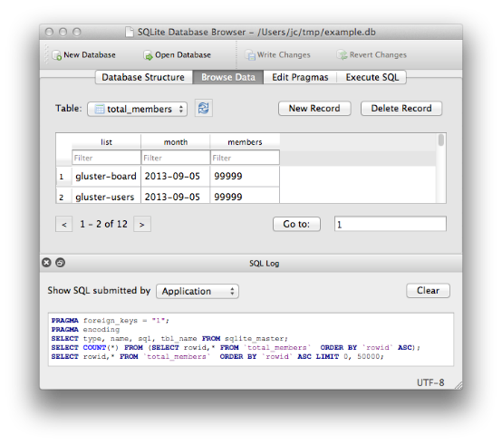

DB Browser for SQLite is a high quality, visual, open source tool to create, design, and edit database files compatible with SQLite.

It is for users and developers wanting to create databases, search, and edit data. It uses a familiar spreadsheet-like interface, and you don't need to learn complicated SQL commands.

**CHAPTER-5**

**CONCLUSION**

* 1. **Summary:**

Henceforth we can conclusively say that the report suggests that the project is essentially based on the idea of multitasking and saving time and energy. It is our common knowledge that Solution like ERP are pretty effective search engines but still one has to go back and forth and type and retype the contents to be searched. So by making this application we selected a variety of categories and listed best Solution of each category so that the hassle of multiple tabs and going back and forth is effectively avoided. Also many future enhancements and a lot of bug fixes will be made in this application to make the interface more user friendly as well as to keep GUI latest and updated.

**FUTURE SCOPE**

This project provides a very unique and diverse solution to the problem that comes with multitasking. We definitely would like to improve and develop this project further as there is a lot of scope of improvement.

The Project can be developed in future with various new feature designs such cross platform mobility , cloud connectivity and other various bug fixes and Improvements and suggestion depending upon the user Review .

**REFERENCES**

* www.codeproject.com › Articles › Mobile Development › Android › Genera
* <http://doc.qt.io/qt-5/index.html>
* <http://doc.qt.io/qt/qabstractitemmodel.html>
* <https://en.wikipedia.org/wiki/Qt_%28software%29>
* <http://doc.qt.io/qt-5/examples-sql.html>
* <https://www.youtube.com/watch?v=3XE2bKUAxfw>